Personal blog: for HTML language

Anas Al.Subhai , ID: 3902990

Mshari Al.Juhani , ID: 3702867

Khaled Al.Muqati , ID: 3704093

# Introduction

The personal blog we have worked on is a blog about HTML language to help students interested in web engineering understand how to write a code about html.

# Home page

It is a page that has cards all the cards are different in the form of frames and each card explains a blog and show you how to write it such as:

# Texts:

Explain how we can change size of the line (h1.h2) and so

# Multimedia:

explain how to involve videos in your page if you want it auto play or not and how you can add pictures the shape and the size you like, also a practice of adding audio

# Forms:

Explain how form looks inside the page and some example such as input (text, password, e-mail, checkbox, range .. etc.)

# Page Design:

The Figures below shows the user interface of Home page

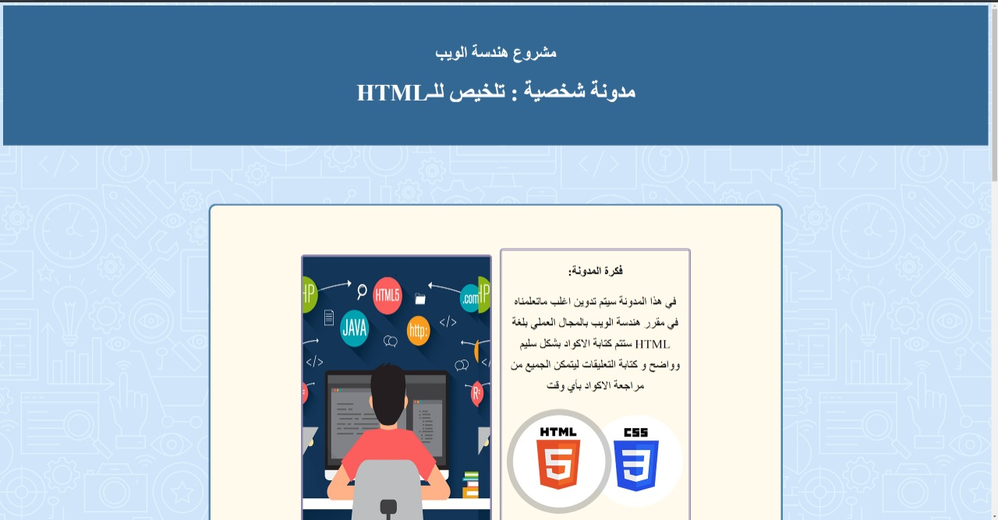

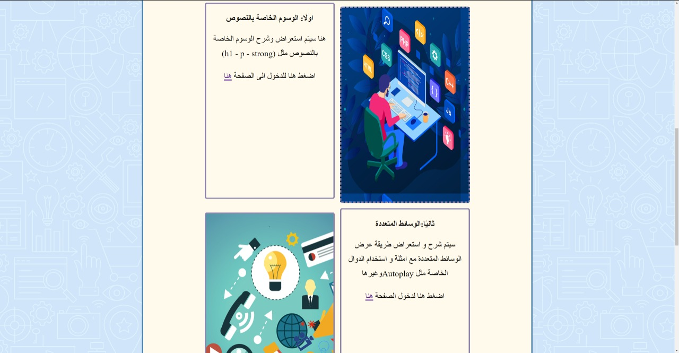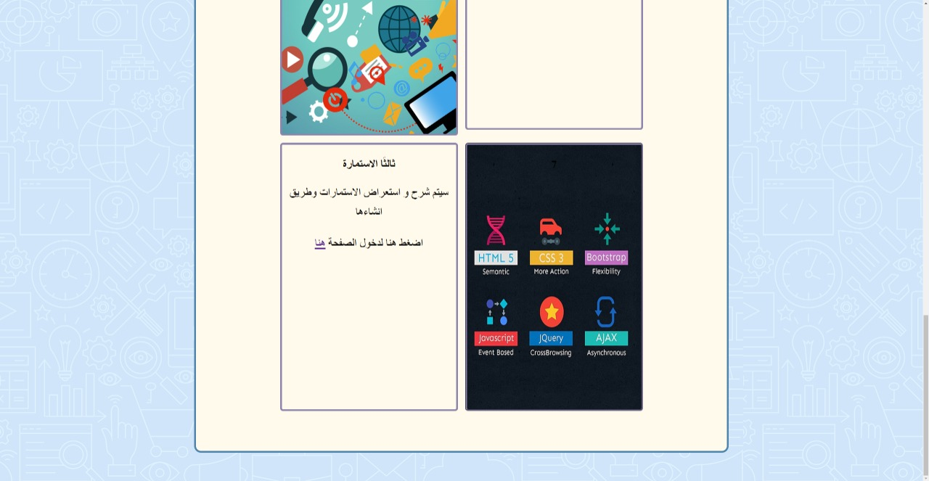

As we see in every line we have two Pictures, First line is description of our project

# Text Page:

second line when you click at the picture with a description statement you will go to another page for practice and example .. Figure below shows the first page called "الوسوم الخاصة بالنصوص"

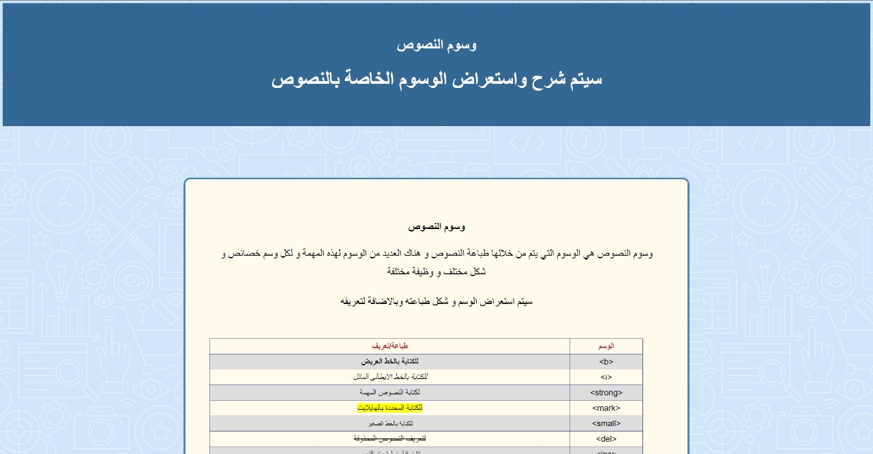

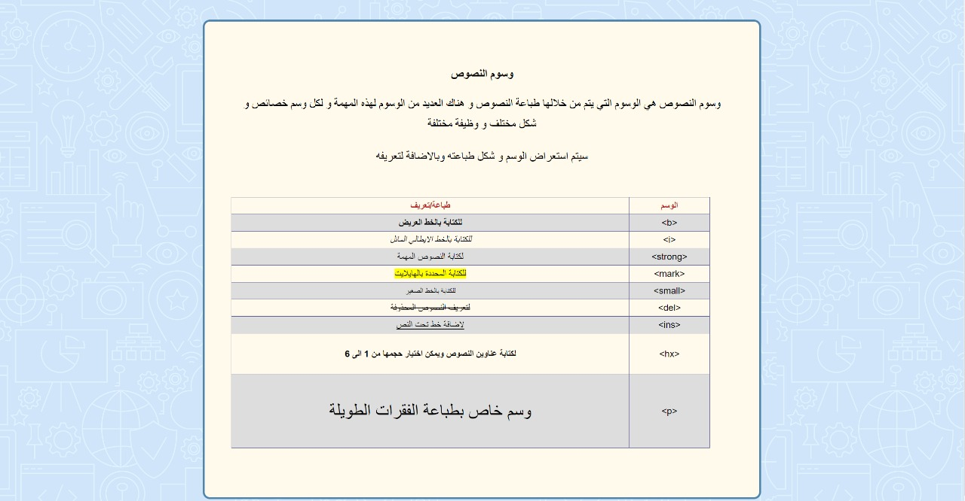

# Multimedia Page:

You can go to Multimedia Page through clicking the description statement picture in third line, its include practice and example of Images, Video and Audio Figures below shows

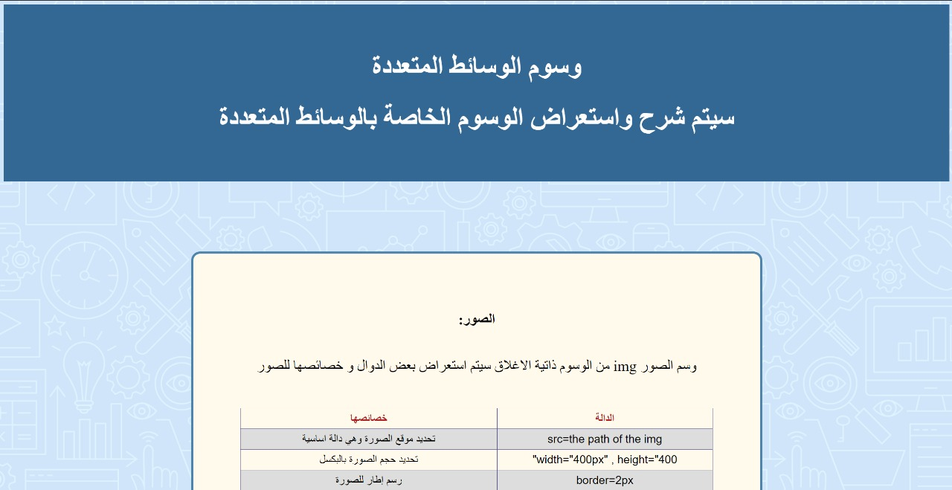

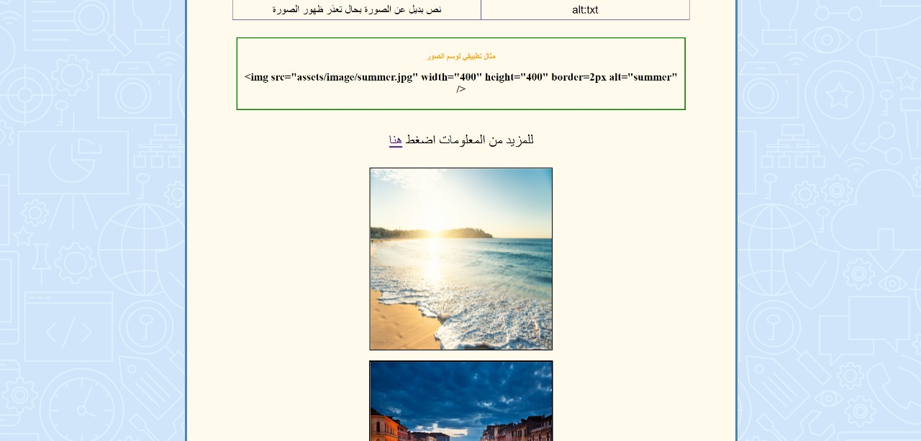

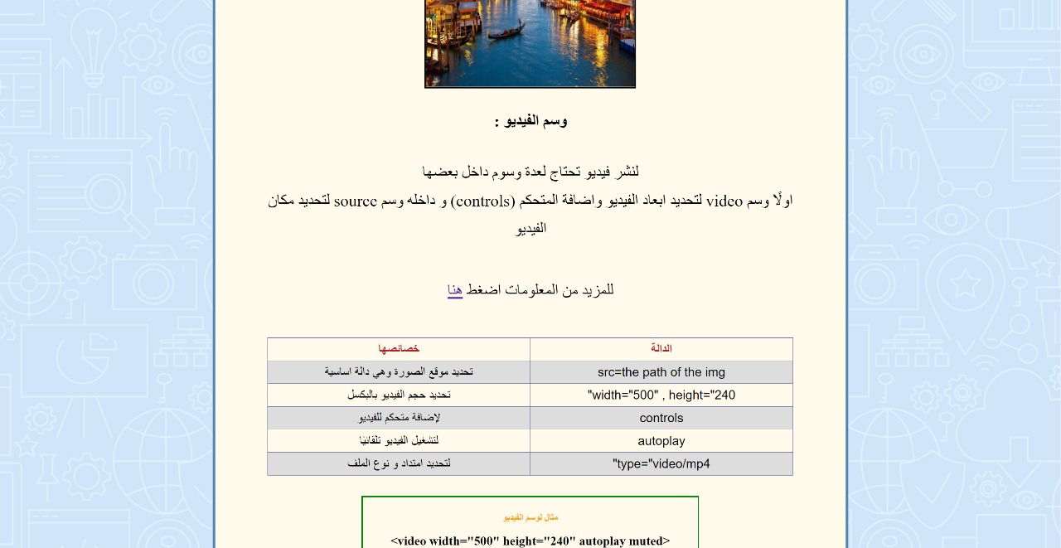

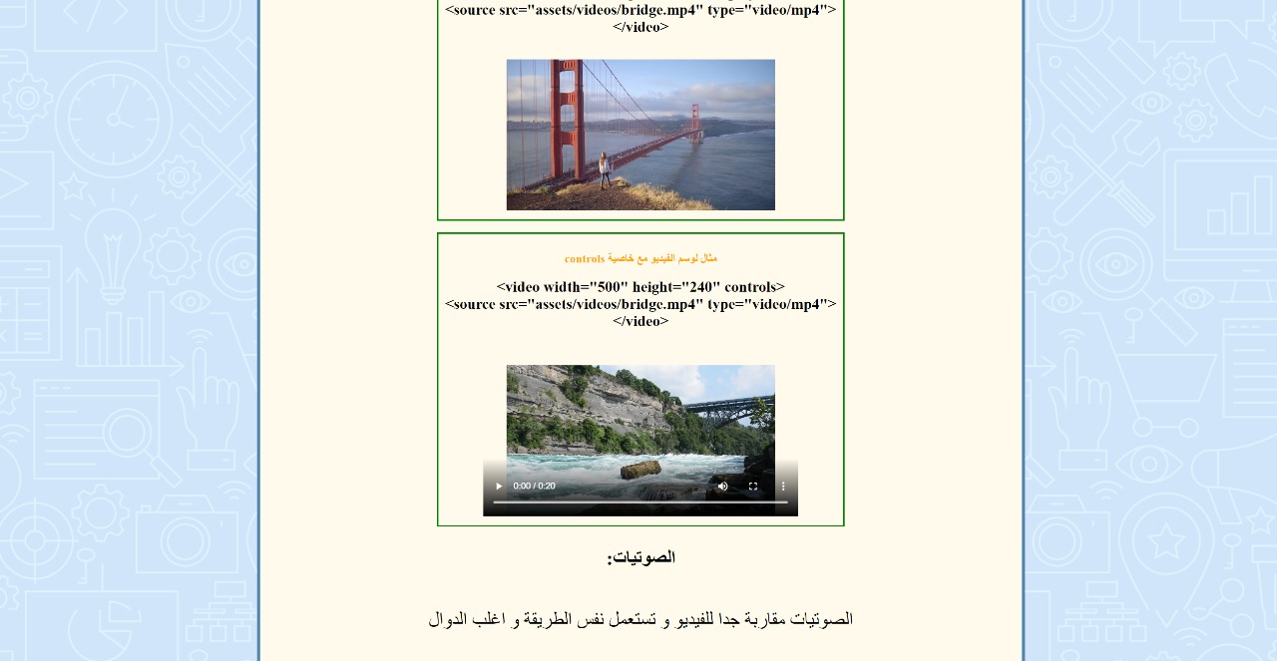

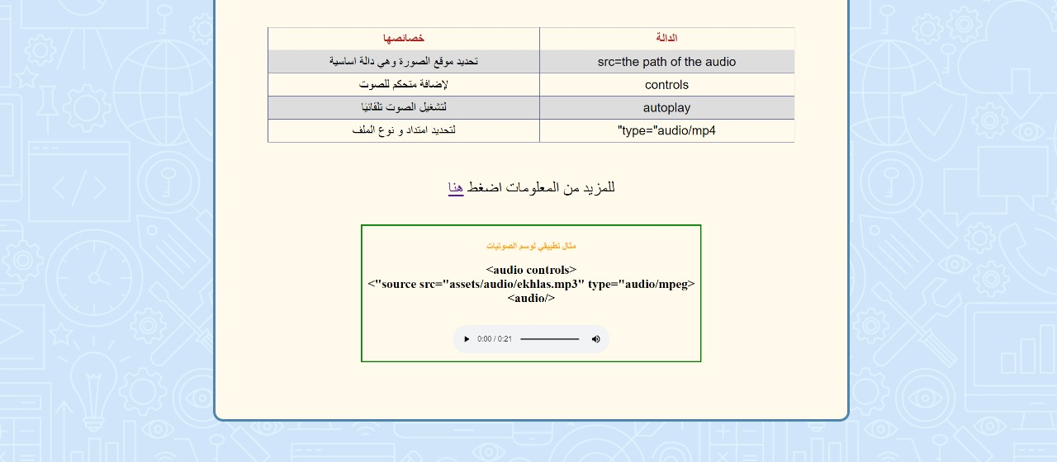

# Forms Page:

You can go to Forms Page through clicking the description statement picture in fourth line, its include examples of input

Figure shows :

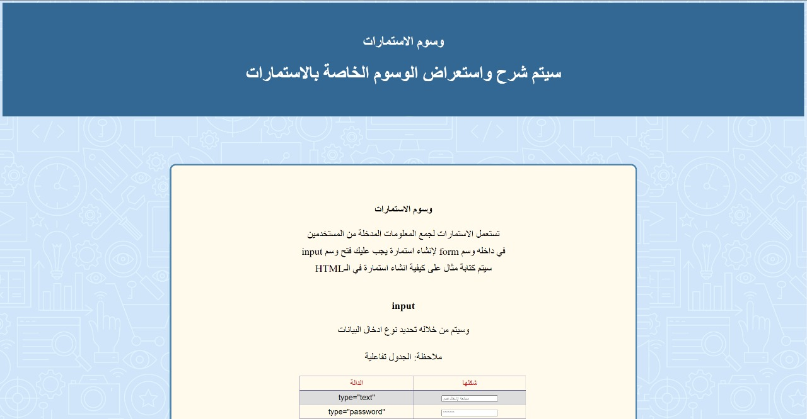

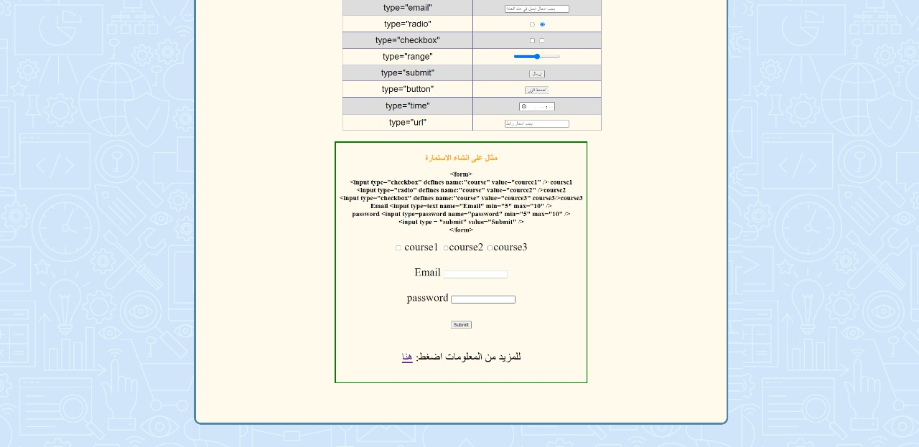

# Coding sample (implementation)

* Home page code:

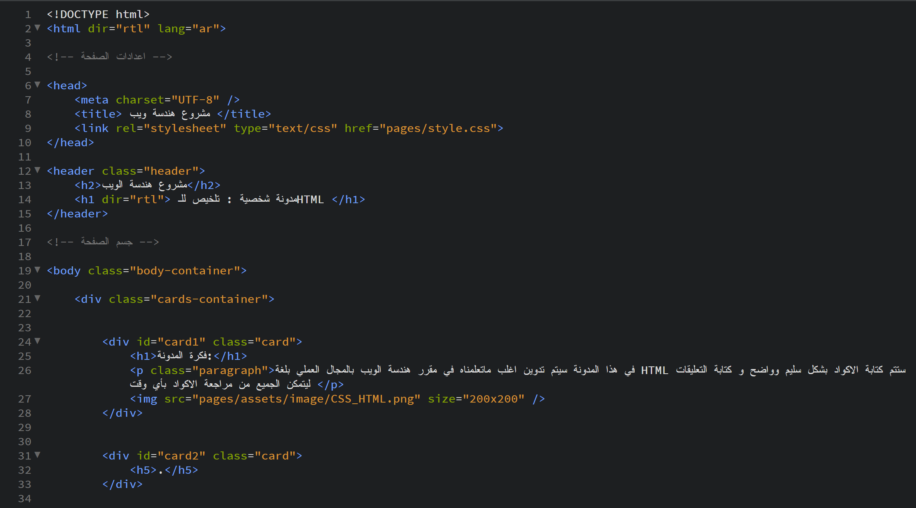

* Text page code:

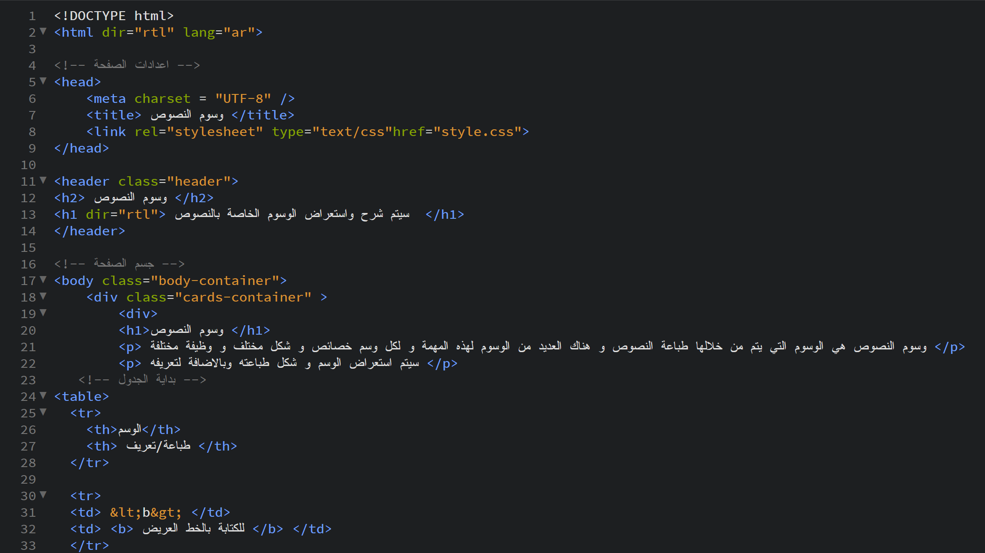

* Multimedia page code:

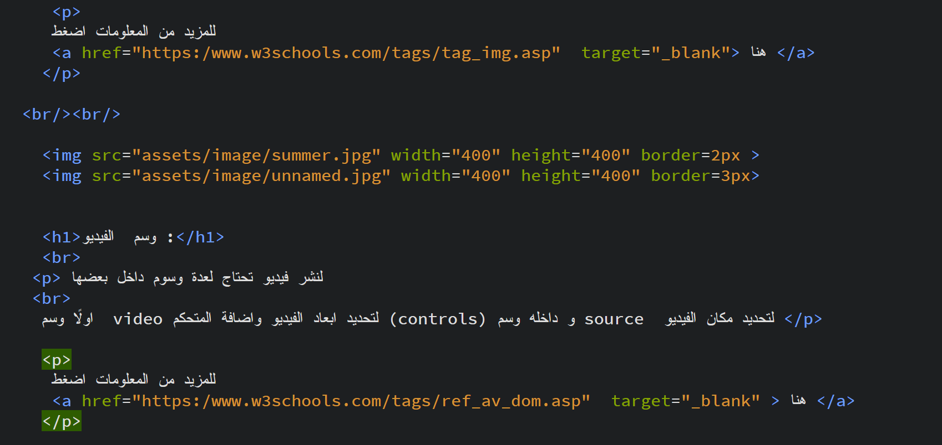

* forms page code:

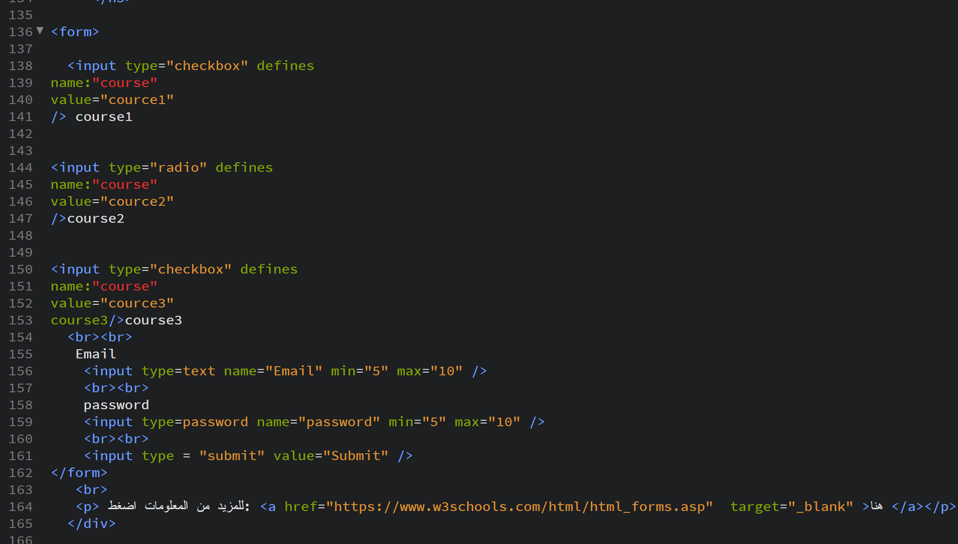

* CSS code

